caGrid Query Handling Use Case
NCIA

Last Revised: | 7/25/2008
Produced By: | NCIA team

Document Approvals
The list contains the name and contact information for the core project team and any key stakeholders who have an interest in the success of the project. An “S” identifies persons responsible for approval from the stakeholder groups. Sign off of the document would be required when a decision is made not to take action for defined gaps.

S | Name | Role
S | Anand Basu | NCICB Engineering Manager
 | David Palmer | Project Manager
 | Jennifer Zeng | Technical Lead
 | Larry Holeman | Requirements Analyst
S | John Freymann | Customer Liaison
Revision History
When you make a change to a document, you must add an entry to this Revision History table and you must manually type the Last Revised Date on the front cover.

Date | Version | Description | Revised by
7/11/2008 | 0.1 | Initial version | Larry Holeman
7/25/2008 | 0.2 | Added retrieve image uc | Larry Holeman
Copyrights and Trademarks
© Copyright 2008 by NCICB, caBIGTM. All rights reserved.

Table of Contents
1.0 Use Case ID: 5
2.0 Primary Actor 5
2.1 Secondary Actors 5
3.0 Brief Description 5
3.1 References 5
3.1.1 Associated Use Cases 5
4.0 Conditions 5
4.1 Pre-Conditions 5
4.2 Post Conditions 5
5.0 Flow of Events 5
6.0 Data Description 5
7.0 Notes 6
8.0 Requirements 6
9.0 Domain objects and CQL example 6
10.0 Sample Modalities, Anatomical, Collections, Available on NCIA 7
11.0 Query Results by Subject 7
12.0 Query Results by Study for Subject 7
13.0 Query Results by Images for Series 8

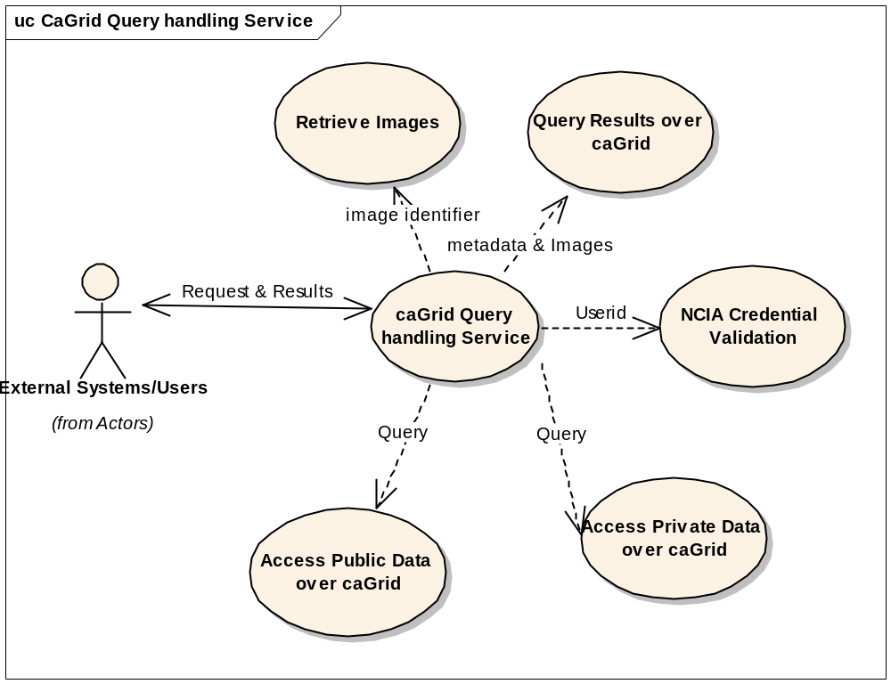
1.0 Use Case ID: |  |  |  |  |  |  | Use Case Name: |  | caGrid Query Handing
2.0 Primary Actor |  |  |  | (Grid user) External user/System that utilizes a frontend conversion process to convert a query request into the standard query request (CQL).

2.1 Secondary Actors
3.0 Brief Description |  |  |  | This Use Case describes the capability to provide the ability for users and systems to query via the NCIA data service API and access one or more images and other data objects across the grid. An external user at remote sites uses their external systems such as I-Response, VirtualPacs, and XIP Host to access NCIA Image repository through the NCIA caGrid. The initial implementation is for public data only. A caGrid user may submit a query with or without a NCIA account. If the user does not have a NCIA account, the user is treated as a guest with access to public data only. If the user has a NCIA account, the userid is authenticated, however, in the first implementation the user will only have access to public data.
3.1 References |  |  |  | - Future request Tracker (https://gforge.nci.nih.gov/tracker/?func=detail&group_id=312&aid=6867&atid=1285)  - 7189 Grid Security https://gforge.nci.nih.gov/tracker/?group_id=312&atid=1285&func=detail&aid=7189  - (http://www.cagrid.org/nwiki/index.php?title=CaGridtransfer)  - NCIA Data Security for caGrid Transfer Working Paper L:\NCICB\NCIA\Tracker Supporting Material\7189-Grid Security
3.1.1 Associated Use Cases |  |  |  | 1. NCIA Credential Validation  2. Access Public Data over caGrid  3. Access Private Data over caGrid  4. Query Results over caGrid  5. Retrieve images
4.0 Conditions |  |  |  | State of the system before and after execution of this use case
4.1 Pre-Conditions |  |  |  | - External System/user has established connection to the caGrid and is communicating with NCIA  - External System/user has logged on to the workstation with their grid credentials  - All access to NCIA over the caGrid is from a provisioned Grid user  - Grid User accounts and NCIA User account IDs have been synchronized
4.2 Post Conditions |  |  |  | Data has been retrieved from NCIA
5.0 Flow of Events |  |  | Trigger |  |  | Actor |  | System |  | Exception
 | 1 | caGrid user access caGrid |  |  |  | caGrid User transmit a query |  | Invoke NCIA Credential Validation
 | 2 | Query request for public data |  |  |  |  |  | Access Public Data over caGrid
 | 3 | Query request for private data |  |  |  |  |  | Access Private Data over caGrid
 |  | Indicator to retrieve images |  |  |  |  |  | Retrieve Images
 | 4 | Data is retrieved |  |  |  | caGrid User retrieves query results |  | Query Results over caGrid
6.0 Data Description |  |  |  |  | Requested data
7.0 Notes |  |  |  |  | None

8.0 Requirements
Requirements for (6867): NCIA system shall provide the ability to down load a group of images over the caGrid Infrastructure.
(6867.1) NCIA shall provide the capability to accept selection criteria in a request for data from external users/sources and return domain Metadata based on the request.
(6867.2) NCIA shall provide capability to accept selection criteria in a request for images from external users/sources and return images based on that request.
(6867.3) NCIA shall provide the capability to accept selection criteria in a request for AIM data from external users/sources and return AIM data based on that request.
(6867.4) NCIA shall provide the capability to validate a user access to data prior to data retrieval.
(6867.5) NCIA shall provide query capability for available image modality meta data from the database.
(6867.6) NCIA shall provide query capability for available anatomical site meta data from the database
(6867.7) NCIA shall provide query capability for available collection meta data from the database
(6867.8) NCIA shall provide the capability for a CQL query to retrieve and return associated meta data for patients, studies, and collections over the caGrid
(6867.9) NCIA shall accept an option that identifies the iterations a query should drill down from the original request: Patients and all their Studies, Series, etc.
(6867.10) NCIA shall provide the capability to return a count and size of a query result set.
(6867.11) NCIA shall provide the capability to return a subset of attributes from a query result set.
(7189.1) The NCIA system shall filter unauthorized requests for private data from a query based on the user’s authorization profile.
(7189.2) The NCIA system shall notify caGrid users (the requester) of unauthorized requests for data.
(15058) Interim Access for NCIA Grid Data Transport

9.0 Domain objects and CQL example
Domain Data Objects  a. ClinicalTrialSponsor  b. ClinicalTrailProtocol  c. ClinicalTrailSubject  d. ClinicalTrailSite  e. TrailDataProvenance  f. Patient  g. CurationData  h. Study  i. Annotation  k. Equipment  l. Series  m. Image | 1. Data Request Sample  The request will be converted regardless of source to a CQL Query Format.  Example: Find Patient with Patient Name = “John Doe” AND Patient ID = “12345”  <Target name=”gov.nih.nci.ncia.domain.Patient”>  <Group logicRelation=”AND”>  <Attribute name=”patientName” predicate=”EQUAL_TO” value=”John Doe”/>  <Attribute name=”patientid” predicate=”EQUAL_TO” value=”12345”/>  </Group>  </Target>

10.0 Sample Modalities, Anatomical, Collections, Available on NCIA
# | Item | Sample Data
1 | Image Modalities | CR,CT,DX,HC,MR,NM,PT, and etc.
2 | Anatomical Site | Abdomen, Chest, CT Cerebrum, and etc.
3 | Collections | LIDC, Phantom, RIDER, and etc.
4 | Available on NCIA | FROM: Date -----TO: Date
5 | Image slice Thickness | A Thickness or a range of thickness

11.0 Query Results by Subject
# | Subject Search Results | Description
1 | Collection ID | Collection identification number
2 | Subject ID | Subject identification number
3 | Studies | Contains two numbers: the number of studies that met the criteria / total number of studies for the subjects
4 | Series | Contains two numbers: the number of series that met the criteria / total number of series
5 | Location | The location of the image
6 | Size | Total size of selected images

12.0 Query Results by Study for Subject
# | Study Search Results | Description
1 | Study Instance Id | Study identification number
2 | Study Description | Short description of study
3 | Date of visibility | Date visible to NCIA
4 | Data Location | Node where data is located
5 | Series | Series ID
6 | # of Images | Number of images in series
7 | Description | Description of the series
8 | Modality | Modality
9 | Manufacturer | Name of the manufacturer
10 | Contains Annotations | Displays and indicator representing yes or no, revealing if there are annotation files
11 | Size | Total size of selected images

13.0 Query Results by Images for Series
# | Series Search Results | Descriptions
1 | Subject ID | Subject Identification number
2 | Study ID | Study Identification number
3 | Date | Date of availability
4 | Modality | Modality
5 | Manufacturer | Name of the manufacturer
6 | Contains Annotations | Displays and indicator representing yes or no, revealing if there are annotation files
7 | Data Location | Displays the name of the center housing the data
8 | Thumbnail | Thumbnail of images
9 | Series Number | DICOM Series number
10 | Size | Size of the image file in megabytes

